2016 MARY F. HAGGERTY, CLA SCHOLARSHIP AWARD
TAKING THE NCCP EXAM IN OCTOBER????
WORRIED ABOUT THE APPLICATION FEE? THIS IS FOR YOU
UP TO 5 SCHOLARSHIPS ARE NOW AVAILABLE FOR THE $125 APPLICATION FEE!
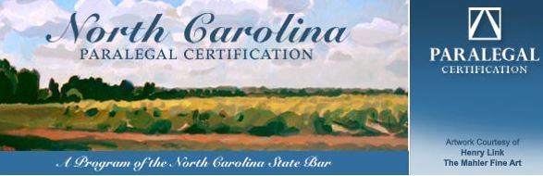
Submit an essay on one of the following two topics:
"What State Certification Means to Me” or “The Advantages and Disadvantages of State Certification”
ESSAY REQUIREMENTS: The essays must be typed, double spaced and on letter sized paper. They may not exceed two pages in length. Include a cover sheet with your contact information. Essays must be emailed by midnight on June 5, 2016 to be considered. DO NOT MAIL. Please be aware that spelling, grammar and punctuation will be taken into consideration!!! The essays will be judged anonymously, so do not reference your name or your paralegal program within the body of the essay.
The final number of scholarships awarded will be at the discretion of the judges.
Participants MUST BE NCPA members in good standing and meet the eligibility criteria for sitting for the October NCCP Exam. Winners will be notified by July 1, 2016. Scholarship fees will be paid directly to the NC State bar. The fees will be refunded to NCPA if the finalists do not sit for the NCCP Exam in October. Winners are responsible for the $50 site fee.
Email your typewritten essay by June 5, 2016 in PDF or WORD format to: info@ncparalegal.org

