AND USING STANDARD .PTX or .ptz FILES WITH REAL LEGAL SOFTWARE
(free viewer download)
Real Legal software has a FREE reader download called E-Transcript Viewer. Any time you receive a .ptx or .ptz file you can download the FREE reader (E-Transcript Viewer) and use this software. It’s much better than only viewing a .pdf transcript. This software is most commonly used by court reporting agencies throughout the United States.
FREE VIEWER DOWNLOAD:
http://info.legalsolutions.thomsonreuters.com/reallegal/software/
viewer allows you to print the following:
FILE, PRINT, TRANSCRIPT – Full transcript, Condensed Transcript, or Keyword Index
Condensed – 4 pages to 1 . 25% the size of a full transcript. (25 pages instead of 100)
Keyword index – might need this to have handy to referenced as you or your attorney looks through a transcript instead of flipping back and forth if they are looking at a hard copy or if you are only looking for specific testimony.

KEY WORD SEARCH
(RESULTS FOR MEDICATION OR RELATED TERMS)
USING SNIPIT TOOL TO SHOW ALL REFERENCES FROM KEYWORD INDEX
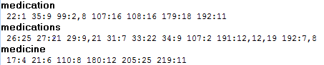
EXCERPT FROM DEPOSITION SHOWING PAGE/LINE REFERENCE
Deposition of Dr Rappaport 6 29 15 Vol 1 Part 1 - Vol. I, (Pages 21:22 to 22:4)
21
22 Q. Okay. You've heard Robert and his
23 colleagues ask this question but -- and I should
24 have asked this earlier on, but is there any reason
25 that we shouldn't go forward with your deposition
22
1 today, any sort of illness, medication, what have
2 you that would impair your ability to answer my
3 questions truthfully?
4 A. No, sir.

EXCERPT FROM DEPOSITION WITHOUT PAGE/LINE REFERENCE
Deposition of Dr Rappaport 6 29 15 Vol 1 Part 1 - Vol. I, (Pages 21:21 to 22:9)
A. Yes, sir.
Q. Okay. You've heard Robert and his
colleagues ask this question but -- and I should
have asked this earlier on, but is there any reason
that we shouldn't go forward with your deposition
today, any sort of illness, medication, what have
you that would impair your ability to answer my
questions truthfully?
A. No, sir.
Q. Okay. If at any point you don't
understand a question, just ask me and I'll
explain, okay?
A. Okay. Fair enough.
Q. Otherwise,

USING .PTZ FILES
Difference between a .ptx file and a .ptz file is the linked EXHIBITS. .ptx files to don’t have electronic exhibits linked within the transcript. .ptz files have exhibits linked.
References all Exhibits and where they appear within a deposition. 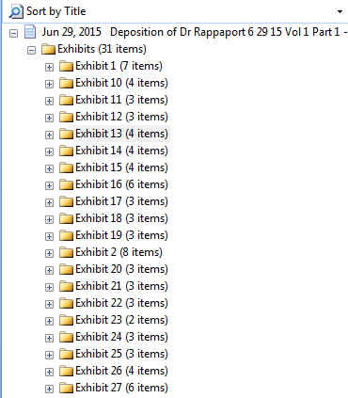
Has hyperlinks to view each actual exhibit.
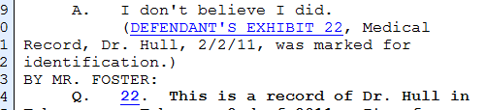

You may search for terms within each exhibit.
Contains a keyword index for each exhibit so you can search for terms within each exhibit.
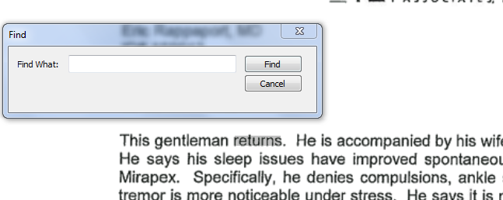

You can use SNIP IT for image copying for mediation, settlement brochures, or case strategy.
Deposition of Dr Rappaport 6 29 15 Vol 1 Part 1 - Vol. I, (Page 35:12 to 35:14)
(DEFENDANT'S EXHIBIT 1, Amended
Complaint and Demand for Jury Trial, was marked for
identification.)
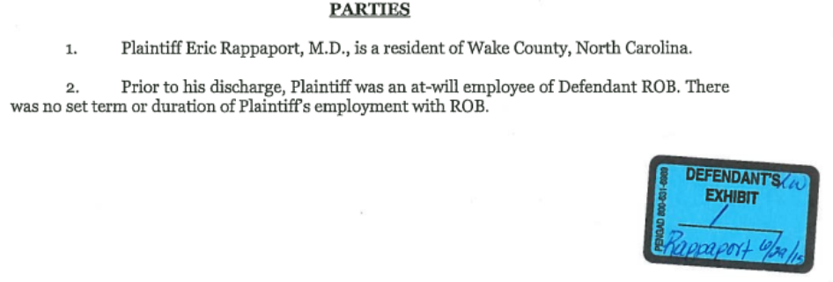

What if
DEPOSITION TRANSCRIPT AND VIDEO SYNCHING BY DEPO VIEW
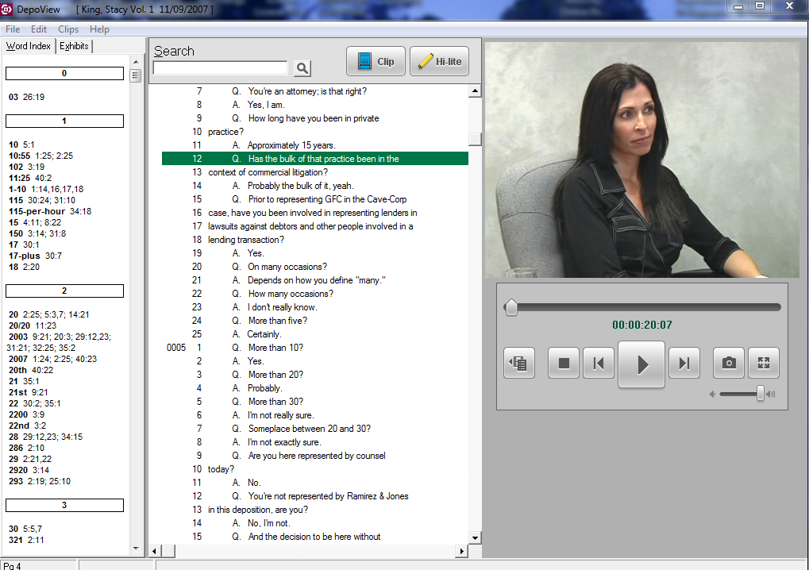
Advantages:
All in one – video, transcript, keyword index, and Exhibits!
Create video clips showing small clips or large clips of the video while following the words in the transcript.
Clips can be exported into Power Point , Trial Director, and other programs to be utilize during trial.

